# What is Git?

Git is a version control system for tracking changes in computer files and coordinating work on those files among multiple people.

It is designed to handle everything from small to very large projects with speed and efficiency.

Git is a Distributed Version Control System. So Git does not necessarily rely on a central server to store all the versions of a project’s files. Instead , every user “clones ” a copy of a repository (a collection of files) and has the full history of the project on their own hard drive.

This clone has all the metadata of the original itself is stored on a self hosted server or a third party hosting service like Github.

# Why use Git?

* **To undo mistakes**: After saving your files you can’t undo your changes so git allows receive your previous files.
* **Distributed Development**: It gracefully handles multiple features of a project parallelly and allows user to merge it into a single file.
* **Don’t mix things up:** For adding new files to the existing file without disturbing the master(main) branch of the project, git provides a option to merge files.

*For example if you want to add new features in your app then you can create new branch and later on merge the file to the master branch.*

* **Community support:** Big support from communities from developers for solving your bugs and errors.

How to install Git?

Download link : <https://git-scm.com/download/win>

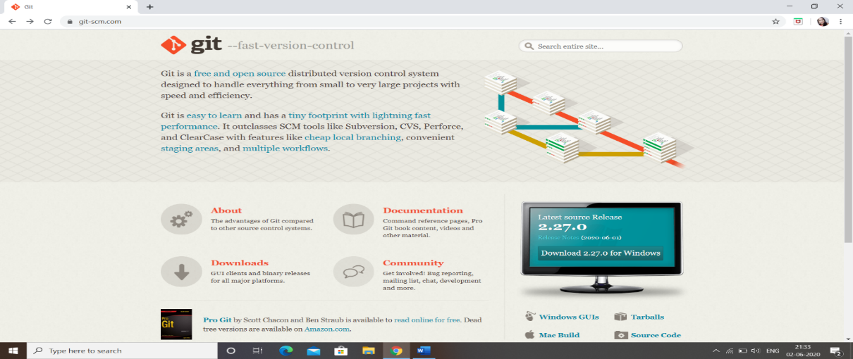

# Git Bash

Git is a source control management system in windows.

It is a command line prompt which is used to give git commands for better versioning and to get the commit history for easier management.

It installs parallelly on installing Github and it can be open through right click on desired place.

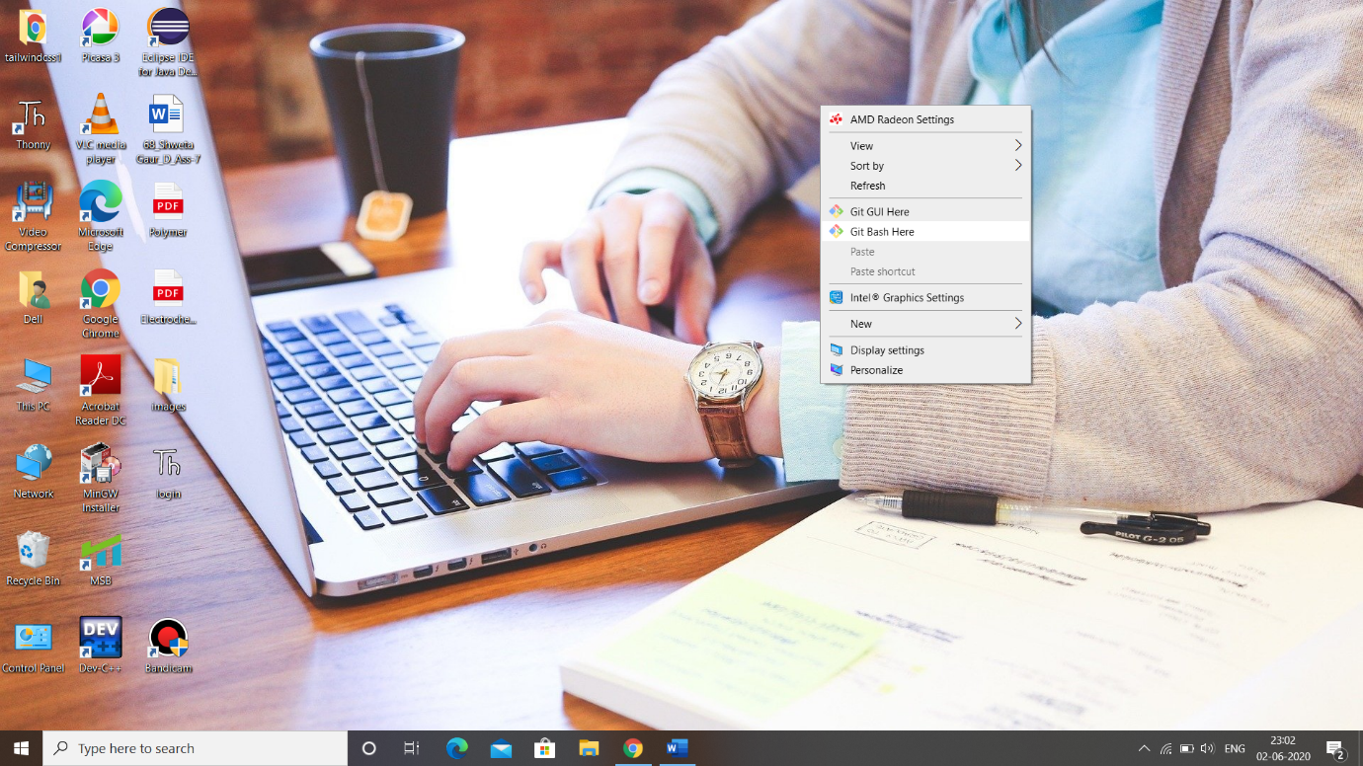

# Git GUI

It allows users to make changes to their repository by making new commits, amending existing ones, creating branches, performing local merges, and fetching/pushing to remote repositories without commands. It provides buttons for giving commands.

Unlike  **git gui,** it focuses on commit generation and single file annotation and does not show project history.

# Basic Git Commands

* git init :- To initialise a git repository for a new or existing project.
* Git add <file name> :- Add one or more files to staging(index)
* Git status:- List the files you’ve changed and those you still need to add or commit
* Git commit -m “commit message”:- Commit changes to head
* Git rm --cached <file name>:- To remove files from Staging area(Unstage)
* Git branch <branch_name>:- To create a new Branch with name as branch_name
* Git checkout <branch_name>:- To switch from current branch to another
* Git merge <branch_name>:- To merge a branch into current branch

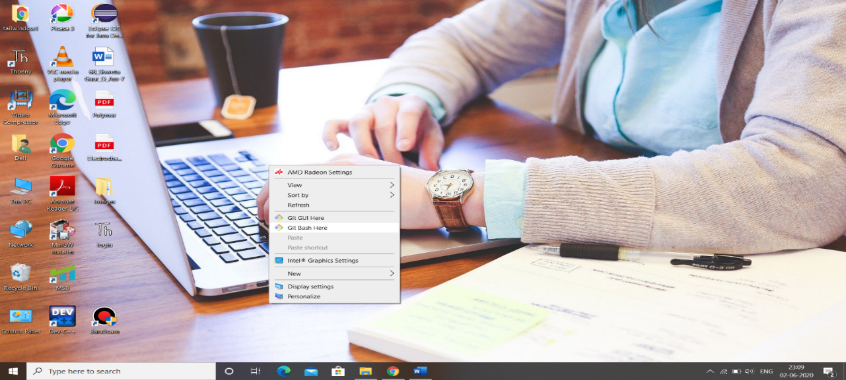

**Git Workflow**

Remote Repo(Master)

Staging Area

Working Directory

Local Repo(HEAD)

(

Git Add

Git Commit

Git Push

Git Merge

Git Fetch

Git Pull

**Clean tree**

All the branch should be finally connected to the master branch for a clean project.

$ git status

On branch master

nothing to commit, working tree clean

# **gGithub**

GitHub is a code hosting platform for collaboration on projects at global level.

You can push your projects from your local system to remote repository either publicly or privately as well as you can copy other people projects to your remote repo for fixing bugs , adding features etc.

How to Push your File (any type)?

1.Download github.

Download link : <https://git-scm.com/download/win>

2.Login / sign up to github (<https://github.com/>)

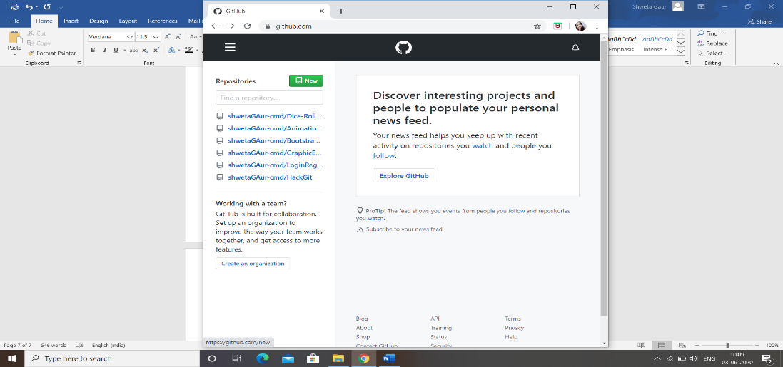3.Click on new(to create a new repo “project”)

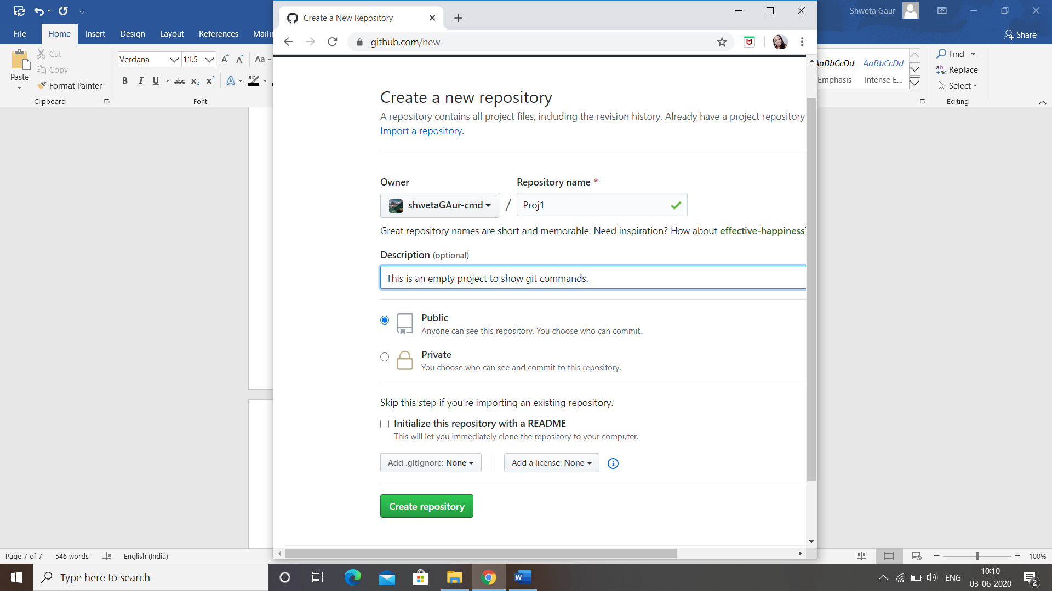4.Give desired repository/repo name.

5.Click on create repository.

6.Select HTTPS/SSH as per your convenience.

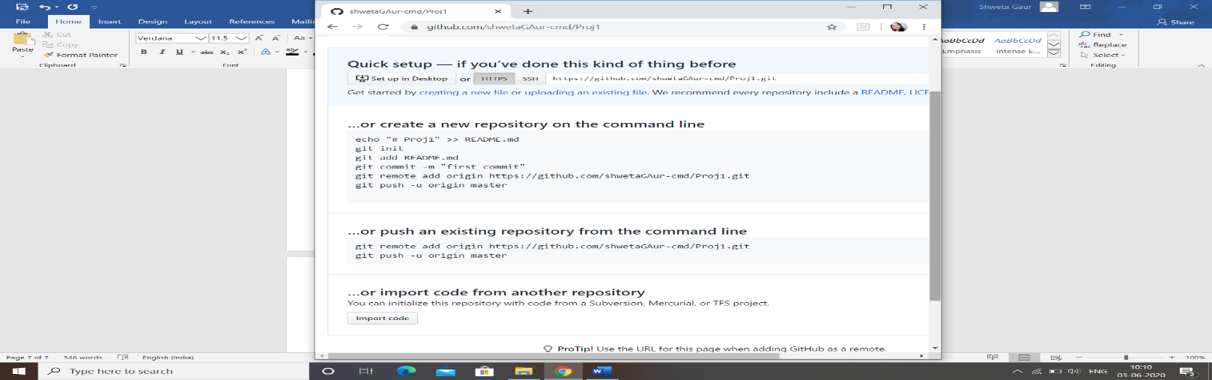

7.Open git bash on at desired directory and give the following commands on git bash or command prompt.

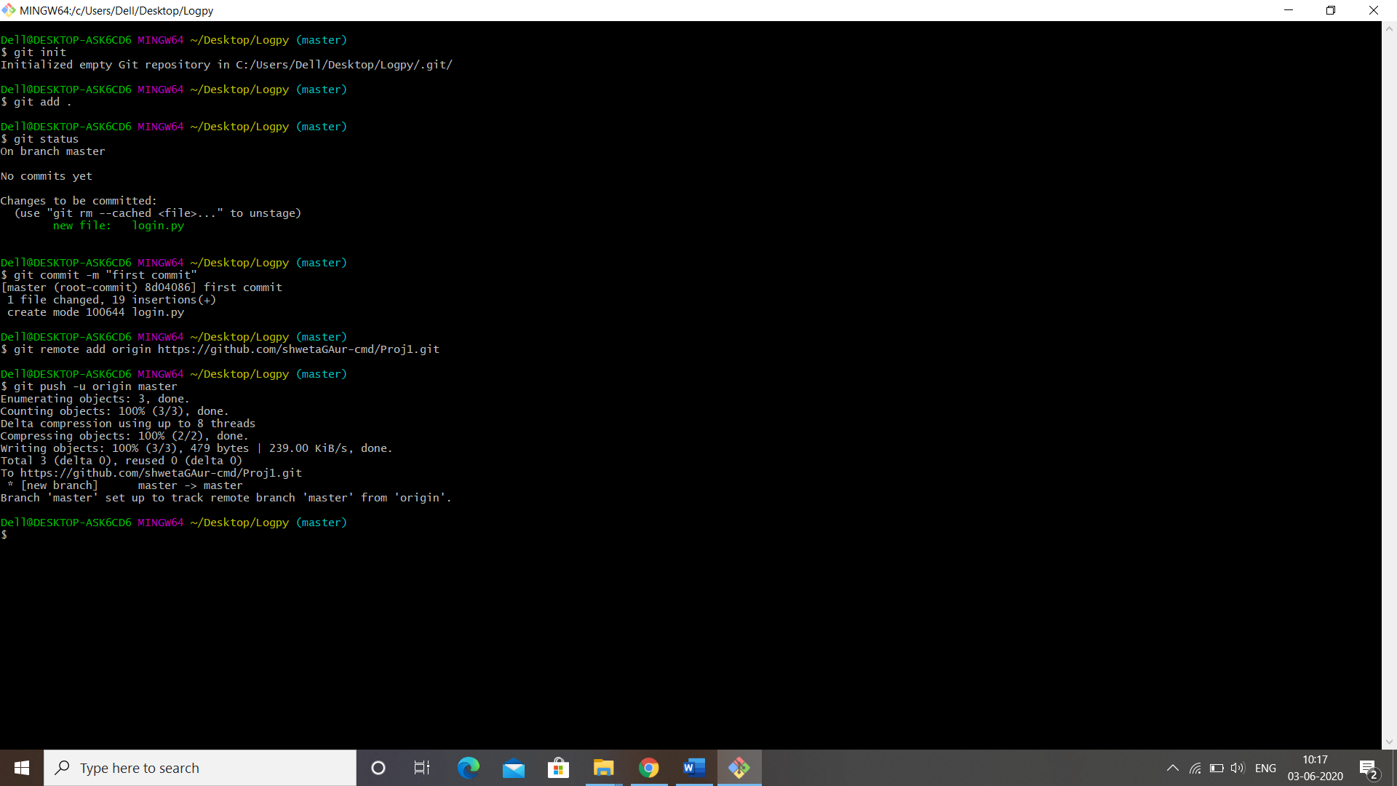

8.Click on project name and your file/Project will be pushed .

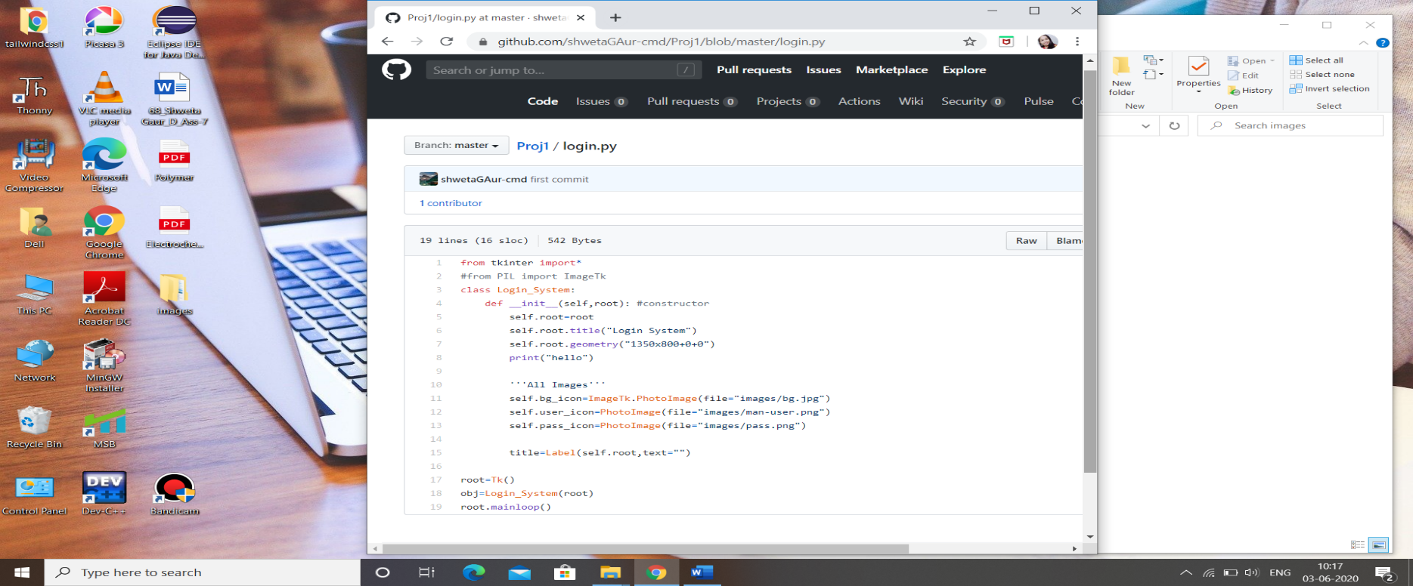

# More Feature of Github…

The process of copying the repository from GitHub to your local system to make desired changes.

1.Click on clone or download

2.Open in Desktop

While working on a project with multiple peoples you may not have the access to merge new branch on master branch . To make it possible it to you can make pull request and later on you can push it on the master branch after making push request in the same way.

Command : $ git pull



It allows you to describe your project through text, snaps, videos, etc.

Command : README.md

**Git Ignore :**

Command : <filename>.gitignore

Sensitive files (eg. API Keys, nodejs modules, etc) which user don’t want to add publicly on remote repo can be saved with the extension “.gitignore“.